

Session: 2021 – 2025

**Submitted by:**

Abdul Mateen 2021-CS-190

**Supervised to:**

Mam Abqa Javeed

Department of Computer Science

**University of Engineering and Technology**

**Lahore Pakistan**

Contents

Task 2

Solution 2

Explanation 2

Code 3

Output 3

# Task

There are X number of account holders of a specific bank, and the total amount of money in their

accounts is G.

When the bank processes a car loan, the software system subtracts the amount of loan granted

for purchasing a car from the total money ( G+ Fixed deposit + Monthly Income Scheme + Gold,

etc.) that the bank has.

It also checks that the difference is more than or not G. It only processes the car loan when the

bank has sufficient money even if all account holders withdraw the money G simultaneously.

Write a program that identifies whether either bank gives car loan or not by using Bankers

algorithm.

# Solution

## Explanation

In this code we prompt user to input certain financial information and determines whether a bank can grant a car loan to an individual or not.

The program first declares several integer variables: X, G, L, F, M, R, and T. These variables will be used to store the input values and calculate the total funds available to the bank.

The program then uses the printf() and scanf() functions to prompt the user to enter the number of account holders, the total amount of money in their accounts, the amount of the car loan requested, the amount of fixed deposits, the amount of monthly income schemes, and the amount of gold or other assets the bank has.

After obtaining these input values, the program calculates the total funds available to the bank by adding together the amounts in the fixed deposits, monthly income schemes, and bank assets, as well as the total amount of money in the accounts.

Finally, the program uses an if-else statement to determine whether the bank can grant the car loan. If the total funds available to the bank minus the car loan amount is greater than or equal to the total amount of money in the accounts, the program prints a message indicating that the bank can give the car loan. Otherwise, the program prints a message indicating that the bank cannot give the car loan.

## Code

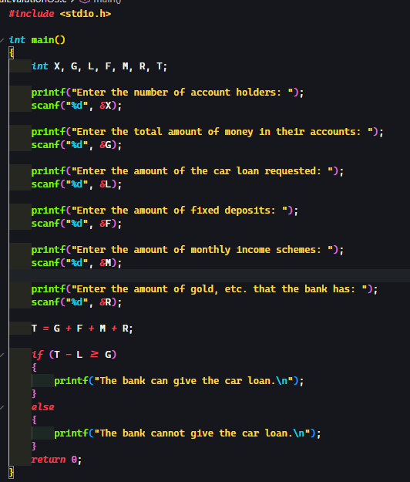

## Output

# 

